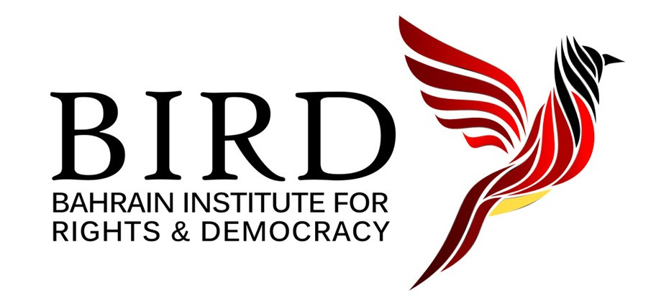

**UN watchdog maintains “B” Status for Bahrain’s Human Rights Body**

Briefing by the Bahrain Institute for Rights and Democracy

November 2024

***Re: Sub-Committee on Accreditation’s Conclusions on Bahrain’s National Institution for Human Rights***

*The Sub-Committee on Accreditation (SCA) of the Global Alliance of National Human Rights Institutions (GANHRI) is an independent UN body that evaluates and accredits national human rights institutions to ensure compliance with international standards.*

In its latest [report](https://birdbh.org/wp-content/uploads/2024/11/2024-GANHRI-SCA-Report-Bahrain-Section-Redacted-4.pdf), published on 20 November 2024, the SCA recommended that Bahrain’s National Institution for Human Rights (NIHR) retain its “B” status, indicating that it does **not** fully comply with the Paris Principles.

**Summary**

The SCA raised critical concerns about the NIHR’s performance, which undermine its credibility as an independent body tasked with promoting and protecting human rights. Significant issues detailed in the report include:

1. Failure to investigate allegations of arbitrary detention, torture, and ill-treatment;
2. Lack of transparency and public accountability;
3. Insufficient engagement with civil society, including human rights defenders;
4. Issues of independence in the selection and appointment of its members

These issues are not aligned with international standards, prevent victims of human rights violations from accessing justice, and undermine trust in the Institution.

The SCA thus made critical recommendations about addressing systematic human rights violations as well as the NIHR’s human rights mandate, meaningful engagement with civil society, and the selection and appointment process.1

**Key issues and concerns**

**Failure to investigate systemic violations**

The SCA criticised the NIHR for inadequately addressing credible allegations of abuse, including **arbitrary detention, torture, and ill-treatment**, particularly in detention facilities.

Specifically, the SCA:

* Stated that the NIHR “not provided adequate information on measures it took to address serious human rights violations including torture and arbitrary detention.”
* Cited the “continued existence of patterns of arbitrary arrest and detention, as well as poor conditions of detention including ill-treatment and lack of access to medical care in Bahrain.”

It also **criticised the NIHR’s narrow interpretation of its mandate**, often deferring cases to other authorities without taking adequate action. Specifically, the SCA:

* Rejected the NIHR’s position that its “mandate [is] limited [...] and that it has followed up on complaints and reports [...] by referring such matters to relevant authorities.”

**SCA recommendation**: The NIHR must interpret the mandate “broadly to independently investigate all human rights violations, including violations committed in places of deprivation of liberty by the military, police, and security officers.”

**Lack of transparency and accountability**

The NIHR’s lack of transparency, especially not disclosing findings from monitoring and investigations of detention facilities, undermines public accountability and trust. Specifically, the SCA:

* Criticised the NIHR for "refraining from publicising its monitoring findings including in relation to visits to places of deprivation of liberty” even though it is “uniquely placed to monitor, investigate and report on systemic violations in this context.”
* Cited that the NIHR’s “public statements, annual reports, and parallel reports [...] include limited to no information on substantive human rights developments in Bahrain.” Moreover, the NIHR has “not taken sufficient action, nor made its positions on these issues publicly available in a manner to promote the protection for human rights in Bahrain.”

**SCA recommendation**: The NIHR must increase “transparency and public accountability” by taking “proactive steps to address systemic human rights issues and to protect all human rights” and publicising its “findings and recommendations” through “public statements, annual reports [...and] parallel reports to international and regional human rights bodies.”

**Engagement with civil society**

The NIHR has neglected its obligation to engage with civil society meaningfully. Specifically, the SCA:

* Noted that the NIHR has “not provided sufficient evidence of effective and meaningful cooperation with civil society organisations (CSOs), including human rights defenders [...] adding that the discussions and outcomes of the consultations are not publicised and that the process lacks transparency."

**SCA recommendation**: The NIHR must strengthen “engagement with CSOs, particularly in the discharge of its protection mandate, and to reinforce its work on the protection of human rights defenders in Bahrain.”

**Lack of independence**

NIHR members, including its chairman and vice-chairperson, are appointed by [**royal decree**](https://www.bna.bh/en/HMKingissuesRoyalOrder392023.aspx?cms=q8FmFJgiscL2fwIzON1%2BDirDIyreTCiLVmBacPVG9Vk%3D), and the selection process for commissioners lacks transparency and democratic safeguards—all of which raise concerns about its impartiality and autonomy. Specifically, the SCA:

* Emphasised that "the criteria for the identification of the full-time and part-time members of the Council of the Commissioners is still not explicit [in Bahraini law]."
* Noted that “the amended Royal Order of August 2023 will only apply for the next appointment of the Council of Commissioners in 2025.”

**SCA recommendation**: The NIHR must advocate for “a clear, transparent, merit-based, and participatory selection and appointment process for selecting full-time and part-time members of the council of commissioners.”

**Similar concerns raised by other UN bodies**

* The UN Committee on Economic, Social and Cultural Rights in 2022 [echoed concerns](https://docstore.ohchr.org/SelfServices/FilesHandler.ashx?enc=4slQ6QSmlBEDzFEovLCuW355pOJr0rR24lZdyERa342g5MY2D5AsPyX8wctmE0i6kyTc0o1OYjVPN%2FZdNdcrZwgvJ1INRezON%2ByY3zylbdqKk5g5j4Z9ka39UGqnvKo8) that the NIHR has not achieved the independence necessary to perform its duties effectively.
* The UN Human Rights Committee 2018 [concluded](https://docstore.ohchr.org/SelfServices/FilesHandler.ashx?enc=6QkG1d%2FPPRiCAqhKb7yhsiMkkhmRBkQVNcBdFYxdTy6GQja8djUQQUivDIkVKQlmvIZ%2BgwjT2jYggAyZn1IEZ2xZ7Toz4WtpBozJ3jO9lHJFL35H4amdve496VIjbPAP) that the NIHR “lacks the independence to perform its functions,” highlighting the opacity surrounding the institution’s handling of complaints and investigations.

**Endnotes**

1 The SCA’s assessment follows its [Second Session of 2024](https://www.ohchr.org/en/countries/nhri/global-alliance-national-human-rights-institutions-ganhri/upcoming-sessions-ganhri-sub-committee-accreditation-sca), held online from September 16-20 and in Geneva from October 14-18. Previously, in November 2023, the SCA had [deferred](https://ganhri.org/wp-content/uploads/2023/11/SCA-Report-Second-Session-2023-EN.pdf) this determination.